Final Project Report – Space Invaders

The game I will be creating is a copy of Space invaders where there is a player who is allowed to move in a set amount of area by using a line to stop the player from passing it, while there are enemies that spawn from the top of the screen as a group of 20-25. The player shoots 1 bullet every 0.5 seconds and the player has to shoot the enemies while the enemies get closer to the player and once the enemies are all dead the second level starts and spawns another 20-25 enemies. When the enemies reach the line of the player’s restricted area the game will finish and the player will lose. I will need to make an array for the enemies because there will be 20-25. I will have an integer variable for a high score. I will have a rectangle for the player and enemies. I will have an image variable which will be put in as the enemy, player and one which is going to be the background of the form. I will have a constant integer variable for how much damage the player’s bullets will do to the enemies. I will have if statements to see if the player shoots, If the player’s bullet comes in contact with the enemy, If the enemy’s health is greater than or less than and equal to 0 to know if the enemy is dead. I will have one method where it will spawn the enemies after every enemy is defeated in the previous round and making the enemies stronger each time the method runs. Another method will be for the player to make him spawn at the bottom of the form every round. Another constant value will be to increase the speed for the enemies as the rounds progress. For the input the first game played will be the high score and change the output to whatever it is, after every time the high score is beaten the output will change to whatever it is. I will have a background of a galaxy to make it look like space. The enemies will be aliens and the player will be a ship that can shoot. I will have another method for whenever the high score is beaten so I can reuse it. I will have a while loop so the player can’t pass a certain part of the screen and move wherever it wants.

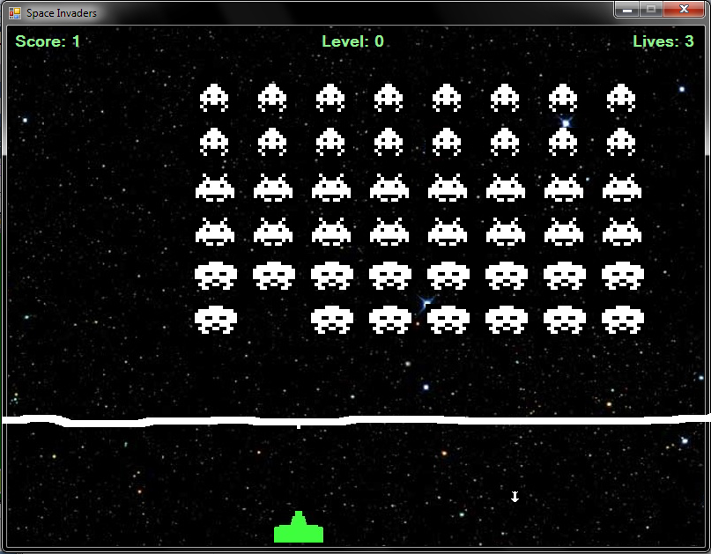  
  
  
  
  
  
  
  
  
  
This image shows the aliens (Enemies) that are slowly moving down, towards the player. While the player has to shoot the aliens before they touch the white line. If the enemies touch the white line then the game will be over and the player will lose. The player cannot cross the white line and has to stay and shoot within the little area between the white line and the bottom of the screen. After every round finishes more enemies will spawn and they will have more health each level that is beaten. Each alien that dies will give the player a score of 10.